Projekt Munka tesztfázis

Topológia

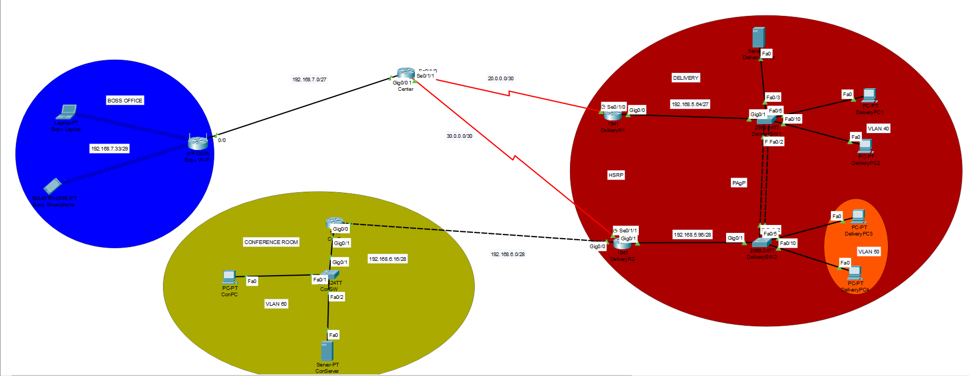

IP tábla

|  |  |  |  |  |  |
| --- | --- | --- | --- | --- | --- |
| Eszköz | Interface | IP | IPv6 | Subnet | Gateway |
| Center | Gig/0/0  Se0/1/0  Se0/1/1 | 192.168.7.1  20.0.0.1  30.0.0.1 | --------------------------------------------------------------------------------------------- | /27  /30  /30 | -------------------------------------------------------------------------------------------- |
| Delivery R1 | Gig0/0.40  Se0/1/0 | 192.168.5.65  20.0.0.2 | 2001:ACAD:DB8:5::2/64  ------------------------------- | /27  /30 | --------------------------------------------------------------------- |
| Delivery R2 | Gig0/0.50  Se0/1/0 | 192.168.5.97  30.0.0.2 | 2001:ACAD:DB8:5::1/64  ------------------------------- | /28  /30 | --------------------------------------------------------------------- |
| ConR | Gig0/0  Gig0/1.60 | 192.168.6.2  192.168.6.17 | -------------------------------------------------------------- | /28  /28 | --------------------------------------------------------------------- |
| Boss Wi-Fi | Internet  LAN | 192.168.7.2  192.168.7.33 | --------------------------------------------------------------------------------- | /29  /29 | 192.168.7.1 |
| DeliverySW1 | VLAN 40 | ------------------------ | -------------- | --------- | ---------------------------------------------- |
| DeliverySW2 | VLAN 50 | ------------------------ | -------------- | --------- | ----------------------- |
| DeliveryPC1 | NIC | DHCP | SLAAC | /27 | 192.168.5.65 |
| DeliveryPC2 | NIC | DHCP | SLAAC | /27 | 192.168.5.65 |
| DeliveryPC3 | NIC | DCHP | SLAAC | /28 | 192.168.5.97 |
| DeliveryPC4 | NIC | DHCP | SLAAC | /28 | 192.168.5.97 |
| DeliveryServer | NIC | DHCP | SLAAC | /27 | 192.168.5.85 |
| Laptop | Wireless | DHCP | -------------- | /29 | 192.168.7.1 |
| Smartphone | Wireless | DHCP | -------------- | /29 | 192.168.7.1 |
| ConPC | NIC | 192.168.6.20 | Stateful | /28 | 192.168.6.17 |
| ConServer | NIC | 192.168.6.25 | 2001:ACAD:DB8:6::1/64 | /28 | 192.168.6.17 |

Vlan tábla

|  |  |  |  |  |
| --- | --- | --- | --- | --- |
| Eszköz neve | Azonosító | Név | Portok | Hálózat |
| DeliverySW1 | 40  99 | Delivery1  Trash | Fa0/5,Fa0/10,Fa0/3  Fa0/6-9,fa0/11-24,Gig0/2 | 192.168.5.64/27 |
| DeliverySW2 | 50  99 | Delivery2  Trash | Fa0/5,Fa0/10  Fa0/3-4,Fa0/6-9,Fa0/11-24,Gig0/2 | 192.168.5.96/28 |
| ConSW | 60  99 | ConVLAN  Trash | Fa0/1, Fa0/2  Fa0/3-24,Gig0/2 | 192.168.6.16/28 |

EtherChannel

|  |  |
| --- | --- |
| Protokoll | Port |
| PAgP | Fa0/1, Fa0/2 |
| PAgP | Fa0/1, Fa0/2 |

Alapbeállítások:

Center:

* Password: cisco
* Minden jelszó titkosítva
* Konzol: console
* Telnet: class

DeliveryR1:

* Password: cisco
* Minden jelszó titkosítva
* Konzol: console
* Telnet: class

DeliveryR2:

* Password: cisco
* Minden jelszó titkosítva
* Konzol: console
* Telnet: class

DeliverySW1:

* Password: cisco
* Minden jelszó titkosítva
* Konzol: console
* Telnet: class

DliverySW2:

* Password: cisco
* Minden jelszó titkosítva
* Konzol: console
* Telnet: class

ConR:

* Password: cisco
* Minden jelszó titkosítva
* Konzol: console
* Telnet: class

ConSW:

* Password: cisco
* Minden jelszó titkosítva
* Konzol: console
* Telnet: class

Linux szerver:

Your name: taco_manager

Servers name: tacos_kft

Username: taco_loco

Password:tastytaco

Groups: taco_managers

Users:

* taco_lajka
* taco_varadi
* taco_enyedi

OSPF:

Center:

* Router ID: 10.10.10.10
* Folyamatazonosító: 10
* Hálózatok megadva:
  + 20.0.0.0/30
  + 30.0.0.0/30
  + 192.168.7.0/28

DeliveryR1:

* Router ID: 1.1.1.1
* Folyamatazonosító: 1
* Hálózatok megadva:
  + 20.0.0.0/30
  + 192.168.5.0/26
  + 192.168.5.64/27

DeliveryR2:

* Routerd ID: 2.2.2.2
* Folyamatazonosító: 2
* Hálózatok megadva:
  + 30.0.0.0/30
  + 192.168.5.0/26
  + 192.168.5.96/27
  + 192.168.6.0/28

ConR:

* Router ID: 3.3.3.3
* Folyamatazonosító: 3
* Hálózatok megadva:
  + 192.168.6.0/28
  + 192.168.6.16/28

SSH:

DeliverySW1:

domain-name: taco.com

hostname: DeliverySW1

user admin secret admin

crypto key: 1024

version 2

line vty 0 15:

login local

transport input ssh

ConSW:

domain-name: taco.com

hostname: ConSW

user admin secret admin

crypto key: 1024

version 2

line vty 0 15:

login local

transport input ssh

